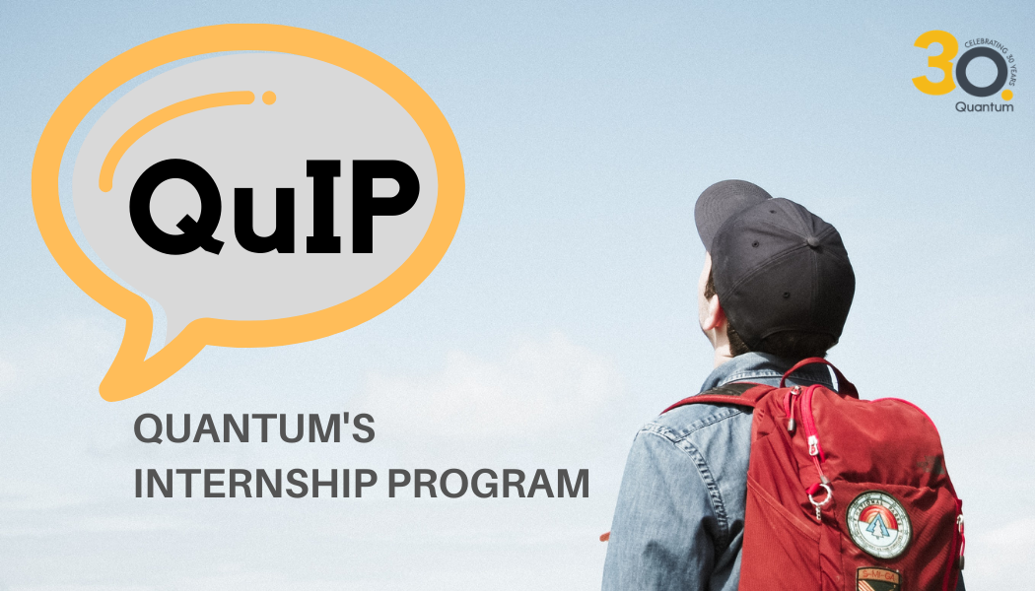

Unleash your potential with Quantum

At Quantum, we believe that centring humans in the business decision-making process is critical to answering the complex questions our clients ask us. We delve into people’s actions, feelings, and circumstances in order to generate key insights for our clients around the globe. Using robust methodologies and frameworks, we translate our findings into strategic directions to guide our clients’ brands and categories.

We are a collective of dynamic thinkers. We run a specialised human / culture strategy consulting company with a global reach of 10 offices across 8 countries in Asia and the United Kingdom. Since we started thirty years ago, we have been constantly pushing the boundaries of the knowledge industry and challenging the status quo. No one can accuse of standing still – we are always adapting and moving forward.

Our unique approach and shared values makes every day at Quantum enjoyable and enriching. The fact that over a third of our workforce has been with us for over 10+ years is a testament to the collaborative and forward-thinking culture we foster. We love the work we do and we’d love for you to join and grow alongside us.

We’re always looking for people who are:
- Curious about culture, human dynamics, brands, technology
- Passionate about storytelling
- Able to clearly communicate
- Ready to step out their comfort zone by thinking in new and unfamiliar ways
- Proactive and collaborative – teamwork makes dream work.

QuIP is four-month paid internship program where you contribute to live client work at various points along the project timeline. You will join project teams to craft and deliver intricate solutions for myriad categories; develop workshops; and hone your analysis skills by working through our arsenal of methodologies and frameworks. And when the work day is done, you will raise a glass (or many) with your colleagues.

You may never want to leave, and that is okay! Intern-to-employee is a legitimate career path at QUANTUM; we would love to have you join us for the long haul.

HOW TO APPLY

Write to: namrata.zatakia@quantumcs.com with the subject line ‘Internship (Insert city name)’. In the body of the email, tell us why you are excited to apply, include the task submission (indicated below), and enclose your CV. We welcome applicants from diverse backgrounds as we believe that transdisciplinary backgrounds, experiences, and mindsets form the backbone of the work we do.

In the body of the email, please respond to one of the following questions:

- With influx of the pandemic, the world has gone digital at a rapid pace. Name two cultural / generational shifts you foresee as a result of lifestyle changes during COVID and elaborate on the nature and consequences.
- Which brands have ‘won the lockdown’ through a demonstration of their cultural relevance and why? What might other brands learn?
- Tell us about something new or something that you revisited during the pandemic. Why should we try it?
- Which one of these three is the biggest driver of future change: Identity, Sustainability or Technology, and why? Alternatively, you can suggest and argue for a different driver of change.

You can complete this task in writing (maximum 400 words); or video or audio format (maximum 2 minutes).

You can submit your response in any form that works for you. For text you can send a word doc, PDF, PowerPoint, or Keynote; for video, .mp4 or .mov with h264 video codec; for audio, mp3 or aac.

Here’s some feedback from some of our former QuIP recruits

“I discovered Quantum Consumer Solutions during my gap year. I wanted to work in an environment where creativity, critical thinking, and teamwork came together seamlessly; the fact that Quantum takes a cultural lens made it even more special. At Quantum, you will meet some of the most friendly, charismatic, and intelligent people in a non-hierarchical, generative workplace. You instantly become a part of the team, carrying your weight in fieldwork, ideation discussions, proposal writing, and debriefs. You also become a part of a community of people who genuinely care about you and want to help you succeed. It's an experience unlike any other; I have learned so much about myself and my capabilities after working at Quantum. Interning here was a wonderful launchpad for me to learn about my career goals and maximise my university experience going forward. Hopefully, I'll be back soon again!”

“My internship at Quantum was one of the few I did right after college. I had no prior experience in the working world. Working at Quantum was an excellent experience for me as I developed a great work ethic and learned to balance it with some fun. The team was very focused and hardworking, with a very encouraging work environment. I learned first-hand the kind of time, and attention research takes and its impact on many aspects of everyday life. Also, a great memory for me is the evening dance sessions I conducted at Quantum, which helped all of us let loose and enjoy ourselves. It was a great learning environment and with a great group of people, and I still carry those learnings with me.”

"Interning at Quantum has been one of the best career choices I have made. As an anthropology major whose budding aspiration is to do cultural research for brands and organizations, Quantum’ strong qualitative research ethos and wide exposure to renowned global brands meant that there was always an exciting project on my plate every day. At Quantum, the highly collaborative team dynamic allowed me to contribute meaningfully to projects in ways beyond the level of a normal internship. I had an empowering experience co-writing slide decks for clients, bouncing insights back and forth with my colleagues, and gaining experience in commercial research methods like semiotics. The team at Quantum are kind, passionate and brilliant and I had such a great time that I returned for a second internship the following year! I would highly recommend the Quantum internship experience as it has built up my foundation in product design and marketing strategy, bringing me closer to my career goals."

